“Pic To Text Converter using Pytesseract”

SUBMITTED in partial fulfillment of the
requirement for the award of the degree
of
BACHELOR OF TECHNOLOGY
IN
COMPUTER SCIENCE & ENGINEERING

Submitted By
PULAKESH MALAKAR (200610007016)
ABDUL KAYUM (200610007001)
KUNAL ARYA (210650007001)
ADITYA BIKRAM PARASHAR (200610007002)
Guided By
MRS. DHARITRI TALUKDAR
(Assistant Professor)
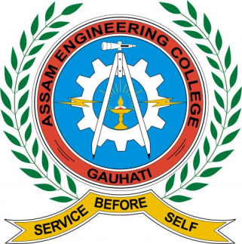

2020-24
ASSAM SCIENCE AND TECHNOLOGY UNIVERSITY, GUWAHATI
ASSAM ENGINEERING COLLEGE, JALUKBARI
GUWAHATI-781013
JUNE-2024
Contents
Forwarding Certificate iii
Forwarding Certificate iv
ACKNOWLEDGEMENT v
DECLARATION BY THE CANDIDATES vi
ABSTRACT vii
Chapter 1- Introduction 1
1.1. Background and Context: 2
1.2. Motivation and Objectives: 3
1.3. Significance and Impact 4
Chapter 2: Literature Review 5
Chapter 3- Proposed Work 17
3.1. Methodology 18
3.2. Tools Required 20
3.3. Model Selection 24
3.4. Model Ready 25
Chapter 4- Results and Discussion 29
4.1. Plain Text 30
4.2. Short Text 30
4.3. Long Text 31
4.4 Handwritten Text 32
4.5. Other Languages 32
4.6. Convert Text 33
4.7. Audio Generation 34
Chapter 5- Conclusion and Future Scope 37
References 39
Appendix 40

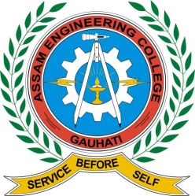

DEPARTMENT OF COMPUTER SCIENCE & ENGINEERING
ASSAM ENGINEERING COLLEGE::JALUKBARI
GUWAHATI-781013

Forwarding Certificate

This is to certify that PULAKESH MALAKAR (200610007016),ABDUL KAYUM (200610007001), KUNAL ARYA (210650007001) and ADITYA BIKRAM PARASHAR (200610007002) have carried out the project work Pic to Text Converter using PyTesseract under the supervision of Mrs. Dharitri Talukdar and have compiled this thesis reflecting the candidates work in the semester long project. The candidat es did this project full time during the whole semester and the analysis, results, claims etc. are all related to their studies and works during the semester.
We recommend submission of this thesis as the partial fulfillment of the requirement for the degree of Bachelor of Engineering in Computer Science & Engineering of Assam Science and Technology University.

Dr.Gunajit Kalita External
Associate Professor (HOD) Name………………...
Computer Science & Engineering Signature……………...
Assam Engineering College Affiliation……………...

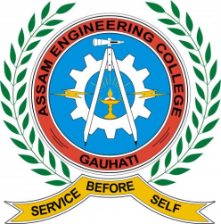

DEPARTMENT OF COMPUTER SCIENCE & ENGINEERING
ASSAM ENGINEERING COLLEGE::JALUKBARI
GUWAHATI-781013

Forwarding Certificate

This is to certify that PULAKESH MALAKAR (200610007016),ABDUL KAYUM (200610007001), KUNAL ARYA (210650007001) and ADITYA BIKRAM PARASHAR (200610007002) have carried out the project work Pic to Text Converter using PyTessaract under the supervision of Mrs. Dharitri Talukdar and have compiled this thesis reflecting the candidates work in the semester long project. The candidates did this project full time during the whole semester and the analysis, results, claims etc. are all related to their studies and works during the semester.
We recommend submission of this thesis as the partial fulfillment of the requirement for the degree of Bachelor of Engineering in Computer Science & Engineering of Assam Science and Technology University.

Mrs. Dharitri Talukdar
Assistant Professor
Signature ……………………...
Computer Science & Engineering
Assam Engineering College, Jalukbari
Guwahati – 781013
Jalukbari , Guwahati - 781013

ACKNOWLEDGEMENT

This project was an excellent learning opportunity for us. We would like to thank everyone who assisted us with this project. First and foremost, we would like to express our heartfelt gratitude to our principal Dr. Kalyan Kalita Sir, the H.O.D of Computer Science and Engineering Department Dr. Gunajit Kalita Sir and the entire Computer Science and Engineering Department. It was a positive experience. We would like to express our sincere gratitude to Mrs. Dharitri Talukdar Ma’am of Computer Science and Engineering Department, Assam Engineering College for her valuable assistance and guidance throughout the project. Mrs. Dharitri’s expertise and insights were instrumental in shaping the initial stages of the project. Her suggestions and feedback during our interactions provided valuable perspectives, which helped us in refining our ideas and establishing a solid foundation for the system. Additionally, Mrs. Dharitri's willingness to spare her time for discussions and clarifications contributed to our understanding of the project's scope and objectives. Her inputs were invaluable in helping us identify potential challenges and devising suitable strategies to overcome them. Finally, we would like to thank all the team members for their cooperation, which enabled us to complete this project within stipulated time.

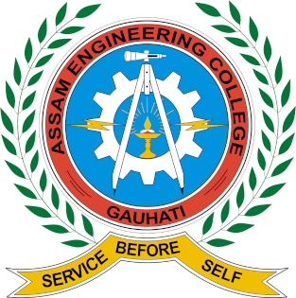
Assam Engineering College
DEPARTMENT OF COMPUTER SCIENCE AND ENGINEERING
ASSAM SCIENCE AND TECHNOLOGY UNIVERSITY,GUWAHATI

DECLARATION BY THE CANDIDATES

We PULAKESH MALAKAR Roll No 20/387, ABDUL KAYUM Roll No 20/007, KUNAL ARYA Roll No. 21/537 and ADITYA BIKRAM PARASHAR Roll No. 20/101 B.Tech Students of the Department of Computer Science & Engineering, Assam Engineering College hereby declare that we have compiled this thesis reflecting all our works during the project as a part of our B. Tech curriculum.
We declare that we have included the descriptions etc. of our project work, and nothing has been copied from other’s work. The facts, figures, analysis, results, claims etc. depicted in our report are all related to our full-time project work.
We also declare that the same report or any substantial portion of this project report has not been submitted anywhere else as part of any requirements for any degree etc

Date: Roll No…...………...Name…………………. Signature.……………….
Roll No…...………...Name…………………. Signature.……………….
Roll No…...………...Name…………………. Signature.……………….
Roll No…...………...Name…………………. Signature.……………….

ABSTRACT

This project leverages the power of PyTesseract, an Optical Character Recognition (OCR) tool, to detect and extract text from images, transforming them into editable and searchable formats. In addition to text extraction, the project integrates text-to-speech (TTS) capabilities to convert the extracted text into audio, enhancing accessibility and usability for users, including those with visual impairments or learning disabilities.
The project begins with the acquisition of images containing textual information, which can include scanned documents, photographs of signs, printed articles, or handwritten notes. Using PyTesseract, the system processes these images to detect and extract the text. PyTesseract, which is a Python wrapper for Google's Tesseract-OCR Engine, is chosen for its accuracy and ease of integration.
Once the text is extracted, it undergoes preprocessing to enhance clarity and correctness. This involves steps like noise reduction, text alignment, and correcting common OCR errors. The cleaned text is then stored in a structured format for further use.
To convert the extracted text into audio, the project utilizes a TTS engine. The text is fed into the TTS system, which generates natural-sounding speech. This audio output is designed to assist users who prefer auditory learning or need assistance due to visual impairments. The audio files can be played back on demand, allowing users to listen to the content instead of reading it.
The final system thus provides a dual functionality: it can extract text from any image and generate an audio representation of that text. This makes it a versatile tool for various applications, including digitizing printed materials, creating audio books, assisting the visually impaired, and enhancing the accessibility of information.
The project demonstrates the integration of advanced OCR and TTS technologies to create an inclusive and accessible information processing tool.

List of Figure:
Figure 4.1 - Plain Text Detection 1 16
Figure 4.2 - Short Text Detection 2 17
Figure 4.3 - Long Text Detection 3 17
Figure 4.4 - Handwritten Text Detection 4 18
Figure 4.5 – Different language Text Detection 5 19
Figure 4.6 - Text Conversion 6 19

Chapter 1- Introduction
  - Background and Context:
The proliferation of digital images in today's world, from scanned documents to photographs containing text, has led to an increased demand for technologies that can accurately extract and process text from images. One such technology is Optical Character Recognition (OCR), which converts different types of documents, such as scanned paper documents, PDFs, or images captured by a digital camera, into editable and searchable data. A prominent tool for OCR in Python is Pytesseract, an open-source Python wrapper for Google's Tesseract-OCR Engine. This project was designed to leverage Pytesseract to detect text from images and then generate audio from the extracted text to enhance accessibility and user experience.
The primary objective of the project was to create a robust system that can automatically detect text from various image formats and convert this text into audio files. The motivation behind this project was to assist visually impaired individuals in accessing written content and to offer an efficient solution for converting physical documents into a format that can be easily consumed audibly. Additionally, the system aims to aid in digitizing and archiving important documents by converting them into a searchable and editable format.
Tesseract-OCR, initially developed by Hewlett-Packard and later maintained by Google, is one of the most accurate and widely-used OCR engines available. Pytesseract serves as a convenient interface between Python and Tesseract, making it easier for developers to integrate OCR capabilities into their applications. Python, with its extensive libraries and ease of use, is an ideal choice for developing such an application, allowing for rapid prototyping and deployment.
For the text-to-speech (TTS) component, several options were considered, including Google's Text-to-Speech API, Amazon Polly, and open-source libraries like gTTS (Google Text-to-Speech). The final choice depended on factors such as accuracy, naturalness of the generated speech, and ease of integration with the OCR component. To further enhance the understanding and accessibility of this text, the following audio file can be generated using a Text-to-Speech service. This audio provides a detailed narration of the project's background and context, ensuring that the information is accessible to a broader audience, including those with visual impairments.
In summary, the project leveraging Pytesseract for text detection and audio generation has successfully addressed the need for accessible and efficient text processing solutions. By combining advanced OCR techniques with state-of-the-art TTS technology, the system provides a powerful tool for converting visual text into audible content, significantly enhancing accessibility for visually impaired users and streamlining the digitization process for various documents.

  - Motivation and Objectives:
In the digital age, the proliferation of visual data has significantly transformed the landscape of information consumption and dissemination. Images, infographics, and scanned documents are now commonplace across various sectors, from academia and business to entertainment and public administration. However, the valuable textual information embedded within these images often remains inaccessible without appropriate tools, posing a challenge for efficient data utilization. This project aims to address this challenge by leveraging PyTesseract, an Optical Character Recognition (OCR) tool, to extract text from images. Additionally, the project integrates text-to-speech (TTS) technology to convert the extracted text into audio, enhancing accessibility and providing a multimodal user experience.
The motivation behind this project stems from several compelling needs and opportunities identified across different domains. For individuals with visual impairments or reading difficulties, accessing textual information in images and documents can be particularly challenging. By extracting text and converting it into audio, this project aims to make information more accessible to these individuals, promoting inclusivity and equal opportunities in information consumption. In professional settings such as legal, medical, and academic fields, vast amounts of information are often stored in image formats like scanned documents. Manually transcribing these documents is time-consuming and prone to errors. Automating this process with OCR technology significantly enhances efficiency, allowing professionals to focus on more critical tasks. Many historical documents and manuscripts are preserved as images. Extracting text from these documents using PyTesseract can facilitate digital archiving and indexing, ensuring that valuable historical information is searchable and accessible for research and educational purposes.
The project sets forth several key objectives to realize the aforementioned motivations: The primary objective is to develop a robust system using PyTesseract that can accurately detect and extract text from a wide variety of images. This includes handling different fonts, sizes, orientations, and languages, ensuring high accuracy and reliability. Once the text is extracted, the next objective is to integrate a reliable TTS engine that can convert this text into clear and natural-sounding speech. This involves selecting a TTS engine that supports multiple languages and can handle the nuances of pronunciation and intonation effectively. To maximize usability, the project aims to develop an intuitive user interface that allows users to upload images, view extracted text, and listen to the audio output with minimal effort. This interface should be accessible across various devices, including desktops, tablets, and smartphones. Overall, this project represents a significant step towards bridging the gap between visual data and accessible information, fostering an inclusive digital environment where information is readily available to all, regardless of visual or reading.
  - Significance and Impact
In an era where digitization is paramount, projects that bridge the gap between physical and digital information play a crucial role. One such project that stands out involves the use of PyTesseract for text detection from images, combined with a text-to-speech (TTS) system to convert the detected text into audio. This project harnesses the power of Optical Character Recognition (OCR) and TTS technologies, significantly impacting various sectors by improving accessibility, efficiency, and user experience.
One of the most profound impacts of this project is its potential to enhance accessibility for individuals with visual impairments. By using PyTesseract, the project can accurately extract text from images, such as printed documents, signs, or handwritten notes. This text can then be converted into speech, allowing visually impaired users to access and understand written content without the need for braille or other assistive technologies. This capability empowers visually impaired individuals by providing them with greater independence and ease of access to information that was previously difficult to obtain.
Moreover, this project can be instrumental in aiding individuals with dyslexia or other reading disabilities. The combination of text detection and TTS can help these individuals by providing an auditory representation of the text, thereby improving their comprehension and learning experience. This application is particularly beneficial in educational settings, where students with reading difficulties can use the technology to better understand their study materials.
In the business world, this project can significantly streamline various processes. For instance, companies that handle large volumes of paper documents, such as invoices, receipts, or contracts, can use PyTesseract to digitize these documents efficiently. Once the text is extracted, it can be stored, searched, and processed electronically, reducing the need for manual data entry and minimizing the risk of human error. This automation not only enhances productivity but also ensures the accuracy and integrity of the data.
In educational settings, the combination of PyTesseract and TTS technology can revolutionize the way information is disseminated and consumed. Educators can use this technology to create accessible learning materials for students with diverse needs. For instance, printed textbooks can be scanned, converted to text, and then transformed into audio books. This approach ensures that students who prefer auditory learning or have difficulty reading can access the same materials as their peers, promoting inclusivity and equal learning opportunities.

Chapter 2: Literature Review
Paper 1. Image to text Retrieval : A Survey on Recent Research and Development: (Nov 2022 | Min Cao , Shiping Li , Juntao Li , Liqiang Nie and Min Zhang) []:
Introduction:
Cross-modal Image-Text Retrieval (ITR) represents a pivotal area in the realm of multimedia information retrieval, aiming to retrieve relevant samples from one modality based on user queries expressed in another modality. Typically, ITR comprises two subtasks: image-to-text (i2t) and text-to-image (t2i) retrieval. With extensive applications in search fields and as a focal point of research, ITR has garnered significant attention. The proliferation of deep learning models for language and vision has propelled the success of ITR in recent years [Frome et al., 2013; Li et al., 2021]. Notably, the emergence of transformer-based cross-modal pre-training paradigms, particularly with the advent of BERT, has revolutionized the landscape. This paradigm's pretrain-then-finetune approach has been extended to downstream ITR tasks, fostering rapid advancements in the field. This literature review explores the evolution, methodologies, challenges, and applications of cross-modal ITR, shedding light on its significance and potential for future developments.

Conclusion:
In conclusion, our review underscores the advancements and challenges within Image-Text Retrieval (ITR). While cross-modal pre-training has significantly boosted performance, issues like data heterogeneity and semantic ambiguity persist. Incorporating scene-text information and high-level knowledge holds promise for future enhancements. Moreover, exploring resource-friendly paradigms, like prompt-based tuning, can address scalability concerns. Overall, our analysis sheds light on the evolving landscape of ITR, guiding future research endeavors for improved cross-modal retrieval solutions.

Paper 2. Image to Text Converter and Translator using Deep Learning and Image Processing(June 2020, Swapnil Sinha, Harsh Kumar Kataruka, Vijayakumar Kuppusamy) ^{[2]}:
Introduction:
Data extraction from images presents a formidable challenge in the realm of image processing. Recognizing text within images demands complex algorithms, yet computer software such as Optical Character Recognition (OCR) offers viable solutions. While various translation tools exist, they often lack user-friendliness. Our project aims to bridge text and interactive visualizations dynamically, leveraging neural networks for text extraction and translation via Google Translator API. Training a suitable neural network involves meticulous mapping of target results and automatic image processing for recognition. With the ubiquity of smartphones, our system targets seamless text extraction from captured images, overcoming challenges posed by diverse backgrounds and text patterns. This introduction sets the stage for exploring the intricate processes involved in text detection, extraction, and translation from smartphone-captured images.
Conclusion:
This paper introduces an innovative solution: an Image to Text converter and translator powered by Deep Learning and Image Processing. It addresses a common challenge faced by individuals encountering text in unfamiliar languages, whether in printed materials or online content. While online translation tools suffice for plain text, the complexity arises with text embedded in images. In such scenarios, especially during travel to unfamiliar locales, language barriers can impede communication and expose individuals to potential exploitation or misinformation. This paper elucidates how our proposed solution mitigates these challenges, offering a seamless and reliable means of understanding and translating text from images in diverse contexts.

Paper 3. A Review on Conversion of Image to Text As Well As Speech Using Edge Detection and Image Segmentation : (Nov 2014, Mrunmayee Patil, Ramesh Kagalkar ) ^{[3]}:

Introduction:

In today's advancing technological landscape, image processing stands out as a dynamic field, utilizing both hardware and software resources to efficiently manipulate visual data. Techniques like filtering, segmentation, and feature extraction enable a wide array of applications, from image editing to object recognition. However, amidst this progress, ensuring inclusivity is imperative, particularly for the visually impaired. With approximately 285 million individuals worldwide facing visual impairments, there's a pressing need for accessible interfaces to engage with the environment effectively.

Our proposed work aims to address this challenge through an image-to-text and speech conversion system designed specifically for the blind. By offering a cost-effective and user-friendly interface, we seek to empower visually impaired individuals to comprehend and interact with various scenarios independently. The system progresses through phases including pre-processing, feature extraction, image segmentation, text conversion, and text-to-speech synthesis, culminating in an intuitive interface that translates visual information into auditory feedback. Through this endeavor, we strive to enhance accessibility and autonomy for the visually impaired, fostering inclusivity in their interactions with the world.

Conclusion:

This survey delves into numerous techniques vital for implementing an image-to-text and speech system, with a particular focus on aiding the visually impaired and physically disabled members of our society. By offering a comprehensive overview, our contribution aims to provide practical assistance and foster greater inclusivity for these individuals. Our endeavor represents a small yet meaningful step towards enabling them to engage more fully with the world around them. Notably, our emphasis lies on object recognition within images, a pivotal aspect for identifying crucial elements. Through this paper, we offer an abstract perspective on various techniques proposed in recent years for image-to-text and text-to-speech conversion, contributing to the ongoing discourse and advancement in this field.

Paper 4. Handwritten Text Recognition Using Machine Learning :(Erram Aishwarya Reddy, Kasireddy Raghuvardhan Reddy, Mohammad Irshad) ^{[4]}

Introduction:

Using CNN's: Handwritten Text Recognition (HT) using Convolutional Neural Networks (CNNs) has become increasingly popular in recent years. The primary benefit of CNNs is their capacity to automatically extract pertinent characteristics from the input picture, which makes them especially well-suited for HTR and other image identification tasks. A

Using RNN's: There are various HTR systems in use today that exclusively use RNNs to recognize handwritten text. The Long Short-Term Memory (LSTM) network, a kind of RNN that is intended to better capture long-term dependencies in the data, is one well-known example.

Using both CNN's and RNN's: There are few HTR systems which are built using combination of the CNN's and RNN's where the data is loaded into the training model is first passed into the set of CNN layers and then the outcome of the CNN layers is passed through the RNN layers to train the model and prepare the model.

Conclusion:

Handwritten Text Recognition is an important application of machine learning that has the potential to significantly improve productivity and efficiency in various industries. The use of Convolutional Neural Networks and Recurrent Neural Networks has proved to be an effective approach to achieve high accuracy in recognizing handwritten text. CNNs are used for feature extraction from images of text, while RNNs are used to model the sequential nature of handwriting. Now that several neural network designs have been merged, it is feasible to develop sophisticated models that have a high degree of handwriting recognition accuracy. However, the quality of the training data and the tuning of the hyperparameters have a significant impact on how well the Handwritten Text Recognition system performs, just like with any machine learning model. It is essential to thoroughly test and assess the model to ensure that it performs well with a variety of handwriting inputs and styles. Planning and executing tests for handwritten text recognition should consider the unique qualities and challenges of this application as well as the need to test for accuracy, robustness, and scalability.

Paper 5: Text Extraction Systems for Printed Images: (A Review Neeru Saxena,Humera Parveen) ^{[5]}

Introduction:

Comprehensive meta-indices for increasing information provide knowledge seekers with a deeper understanding of specific domains. Researchers have extensively studied text and non-text detection and extraction techniques, including handling multi-font, multi-oriented, colored, and black-and-white images, as well as multi-script documents. A comparative survey of various English text and content extraction approaches from printed documents. These techniques follow the basic principle of text extraction models, starting with scanning and preprocessing and culminating in the extraction of text, characters, and lines.

During preprocessing, algorithms perform tasks such as noise removal, skew detection, exclusion of circles and lines, image width reduction, graph weight computation, smoothing, gray-to-binary conversion, and normalization. Most algorithms also perform word, line, and page detection and segmentation to extract characters. Some techniques include separating text and non-text regions, while others focus on character recognition across multiple applications. These approaches employ key concepts like Fuzzy C-means, Gaussian distribution, HMM Character models, ridge detection, image inversion, character rotation, and genetic algorithms.

Conclusion:

This paper presents a comparative study and review of text detection and extraction from printed images (TDE-PI), evaluating existing approaches and their effectiveness. Key aspects and solutions are analyzed, forming the foundation of the proposed system. Our research offers a formal analytical description of complex text detection and extraction, considering various recognition factors. Numerous TDE-PI systems have achieved high accuracy, as shown in the graphical analysis, highlighting content extraction and multi-font recognition as critical future focuses. Future work may explore multi-script TDE-PI algorithms for complex and degraded documents, further testing their appropriateness and reliability.

Paper 6: Image Processing and Text Extraction Python ( Deepika S) ^{[6]}:

Introduction:

This paper provides an overview of various text recognition techniques and algorithms. It discusses the accuracy of different text recognition methods, presenting a detailed flow of the techniques. One paper highlights that no single method can satisfactorily handle all applications due to variations in characters, font, size, and texture. Another paper focuses on enhancing input images to achieve optimal accuracy with Tesseract. The extraction of text from images or documents is emphasized in several studies, with OCR being a common method for improving accuracy and performance. A comprehensive survey explores text information and extraction, noting the lack of public test sets for comparing algorithm performance. An algorithm for offline character recognition is discussed, detailing preprocessing and line detection. Another paper provides an overview of text extraction techniques and proposes a system capable of detecting and recognizing text from various images, with a performance comparison of different methods. These studies highlight the advancements and challenges in text recognition and extraction.

Conclusion :

The main objective of the project is to develop an algorithm that will be used to identify the image and it extracting the data or text using OCR and it analyze the text from the given image and it display the like both characters and words. This project explains about the implemented of the image processing and text extraction using of an optical character recognition to identifies the PNG and JPG image and recognize and extracting the text from given image and it displaying the data from according their spaces and digit number spaces. It provides given image text to both words and characters and we can also implement given image in different languages.

Paper 7 : Image to Text and Speech Synthesis (Nov 2023 | Keerthi S H, Shravya, Laxmi V) ^{[7]}:

Introduction:

Image captioning, which provides natural language descriptions of an image's content, lies at the intersection of natural language processing and computer vision. Advances in object detection architectures and convolutional neural networks have significantly improved image captioning. Current deep learning-based techniques often use an encoder-decoder framework, where a Convolutional Neural Network (CNN) encoder extracts visual features and a Long Short-Term Memory (LSTM) decoder generates descriptive text sequences. However, these methods focus mainly on factual descriptions and may overlook important scene details.
To address this, attention mechanisms, similar to the human visual system, are employed to selectively focus on relevant image areas, enhancing description accuracy. Popular datasets like Flickr30k and MS COCO are commonly used for training these models. Additionally, Generative Adversarial Networks (GANs) are utilized for text-to-image synthesis, improving the performance of caption generators with synthetic data. Text-to-speech (TTS) synthesis converts text into speech, using algorithms to analyze, preprocess, and synthesize speech that closely resembles native language speakers.

Conclusion:

This project introduces a new navigation system for visually impaired individuals, integrating CNN and image captioning into smart eyewear. The model converts real-time images into textual representations, which are then spoken to the user. Utilizing ResNet50 for superior accuracy, the system bridges the gap between textual and visual modalities, enabling visual information acquisition through speech and text. Despite challenges with low-quality images and complex backgrounds, the results suggest promising future research and practical applications.

Paper 8: Text to Speech Conversion:(S. Venkateswarlu, D. B. K. Kamesh, J. K. R. Sastry and Radhika Rani) ^{[8]}:

Introduction:

Optical Character Recognition (OCR) is a technology that transforms scanned or printed text, including handwritten text, into editable text for various applications. This paper introduces a robust approach for extracting text and converting it into speech. The device's testing was conducted on a Raspberry Pi platform, initially connected to the internet through VLAN. Software installation was achieved using command lines, with steps involving downloading the installation script, converting it to an executable form, and running the script for installation. The setup, as illustrated in Figure 1, includes manually focusing the webcam towards the text. After a 7-second delay to refocus the webcam if necessary, a picture is taken and processed by the Raspberry Pi to convert the text into spoken words, audible through earphones or speakers connected to the Raspberry Pi's audio jack.

Conclusion:

The Text-to-Speech device efficiently converts text images into sound with high accuracy and readability, tolerating less than 2% error. Processing time is quick, averaging under three minutes for A4 paper size. This portable device operates independently without the need for an internet connection, making it accessible for all users.

Paper 9: An Approach for Translation of Text in Images using Deep Learning Techniques: (Ashwini V. Zadgaonkar , Rupali S. Vairagade)^{[9]}

Introduction:

Optical Character Recognition (OCR) is a critical process for converting text within images into machine-readable formats. It involves several stages, starting with Adaptive Binarization, where the image is transformed into binary form to enhance text visibility. Next comes Component Analysis, which identifies individual text components such as characters or words. Finally, the Recognition Phase combines these components to produce an editable document. The Tesseract OCR Engine, developed by Google, plays a pivotal role in this process. It boasts the ability to recognize over 100 languages and adapts to their nuances using machine learning techniques.

On the other hand, Google's Neural Machine Translation (GNMT) represents a significant leap forward in machine translation. Its architecture includes an Encoder-Decoder Framework, where the encoder processes the source language (extracted from the image) to create a semantic representation. The decoder then generates the target language (translated text). Additionally, GNMT incorporates an Attention Mechanism, which improves translation fluency by focusing on relevant parts of the input. This context-aware approach has revolutionized machine translation, providing accurate results across various languages and domains.

Conclusion:

In our interconnected world, language barriers persist as formidable obstacles to effective communication. The proposed system, by seamlessly extracting text from images and providing accurate translations, represents a significant breakthrough. The integration of Optical Character Recognition (OCR) and Google’s Neural Machine Translation (GNMT) ensures reliable translations. OCR extracts text directly from images, while GNMT handles the translation process. Beyond printed signboards, the system adeptly handles handwritten notes and diverse image types. Its adaptability caters to real-world scenarios where text appears in various forms. As demand escalates, the system’s potential expands. Future enhancements may include incorporating handwritten text recognition and supporting additional languages.

Paper 10: Text detection and localization in scene images: a broad review: (Shilpa Mahajan and Rajneesh Rani)^{[10]}

Introduction:

The paper delves into the differences between natural scene images and document images, explaining that natural images often contain text that delivers vital messages, such as shop signboards or traffic signs. The authors discuss the challenges associated with understanding text in natural images, especially for individuals unfamiliar with the language presented. They outline the scope and applications of text detection and localization, mentioning technologies that assist in translating text into other languages, aiding visually impaired persons, and facilitating scene understanding and address identification.
The science behind text detection and localization involves several stages, starting with preprocessing of images to remove impurities and enhance image quality. The authors describe various traditional text detection schemes, such as stroke-based methods, region-based methods, and connected component-based methods, each with its own set of advantages and limitations. They also explore deep learning-based schemes, which have shown significant improvements in text detection and localization tasks.

Conclusion:

In conclusion, the paper presents a detailed analysis of the current state of text detection and localization techniques, highlighting the advancements made through deep learning approaches. The authors provide a comparative study of different methods, datasets, and performance metrics used in the field. They also identify major challenges, such as detecting text in complex backgrounds and handling various text orientations and fonts. The paper concludes with suggestions for future research directions, emphasizing the need for improved methods that can handle the diverse and challenging scenarios encountered in natural scene images.

Paper 11: Image Processing Based Scene-Text Detection and Recognition with Tesseract: (Ebin Zacharias, Martin Teuchler and Bénédicte Bernier)[^{11]}

Introduction:
The paper begins by highlighting the significance of text recognition in automation and its application in reducing human effort. The authors note that while Optical Character Recognition (OCR) is effective for printed text documents, scene text recognition remains a complex task that has only recently attracted attention. The accuracy of OCR is highly dependent on image preprocessing and the quality of the image, with factors such as font size, geometric distortions, and illumination effects playing critical roles.
The project’s main objective is to extract ILU codes (Intermodal Loading Units) printed on swap bodies, which are unique numbers used for tracking in intermodal transport4. The ILU code consists of an owner-key, a registration number, and a check digit. The paper outlines the development stages, challenges, and findings of the project, which achieved a correct character recognition rate of over 80%.

Conclusion:

In conclusion, the paper acknowledges that optical character recognition in natural scenes is a challenging task, with the project achieving an overall accuracy of 83%. The authors suggest that the accuracy could be further improved with better quality input images. However, they also recognize that text recognition is not flawless, especially when subjected to complex environmental conditions. The paper discusses the occurrence of false-positive cases where the checksum number matched with incorrectly detected registration numbers, highlighting the need for further examination of this issue.

Chapter 3- Proposed Work

3.1. Methodology
Pytesseract, a Python wrapper for Google's Tesseract-OCR Engine, facilitates text extraction from images using optical character recognition (OCR). The methodology and working of Pytesseract involve a series of integrated steps that combine Python with the robust Tesseract OCR library, enabling the conversion of visual text into machine-encoded text. The process begins with installation and setup, requiring both the Tesseract OCR engine and the Pytesseract library, which can be installed via package managers or pip, respectively. Additionally, Pillow, a Python Imaging Library, is often used to handle image file operations.
Image preprocessing is a crucial step that enhances OCR accuracy. Techniques such as converting images to grayscale, thresholding, noise removal, resizing, and applying filters are employed to improve text clarity. Libraries like OpenCV and Pillow are commonly utilized for these preprocessing tasks. After preprocessing, the image is ready for text extraction. Pytesseract passes the image to the Tesseract engine, which employs sophisticated algorithms to detect and recognize characters through stages like image binarization, connected component analysis, text line recognition, and character segmentation.
Pytesseract supports multiple languages and can be configured with various parameters to optimize performance. Users can specify languages using language packs, adjust OCR engine modes (OEM), and configure page segmentation modes (PSM) to tailor the OCR process to different document types, such as single blocks of text, multiple columns, or sparse text. The recognized text can be output in various formats, including plain text, bounding box data for each character, and hOCR, an HTML format containing OCR data. This flexibility allows integration of the extracted text into various applications, ranging from simple text processing to complex document analysis tasks.
The working of Pytesseract involves seamless integration with Python. By importing the Pytesseract module, users can interact with the Tesseract engine through Python scripts. Images are loaded into the Python environment using Pillow or OpenCV, and then passed to Pytesseract. Under the hood, Pytesseract executes Tesseract commands via the command line, constructing the appropriate command based on the provided parameters and invoking Tesseract. The process includes specifying the input image, output format, and additional configuration options.
Tesseract processes the image through several internal stages: image binarization converts the image to a binary format, simplifying text recognition; connected component analysis identifies distinct regions in the image that may contain text; text line detection determines lines of text by analyzing the spatial distribution of these regions; character segmentation breaks lines into individual characters; and recognition involves recognizing characters using a trained neural network model. Tesseract has models trained on various languages and scripts, which users can specify.
After processing, Tesseract returns the recognized text to Pytesseract, which provides it to the Python environment. Users can then manage this text according to their needs, such as printing, saving to a file, or further analyzing it. Advanced features of Pytesseract include obtaining bounding box coordinates for each character, generating searchable PDFs or hOCR output that embeds OCR data within an HTML format, and configuring custom settings to fine-tune the OCR process, such as limiting recognized characters to a specific set for improved accuracy.
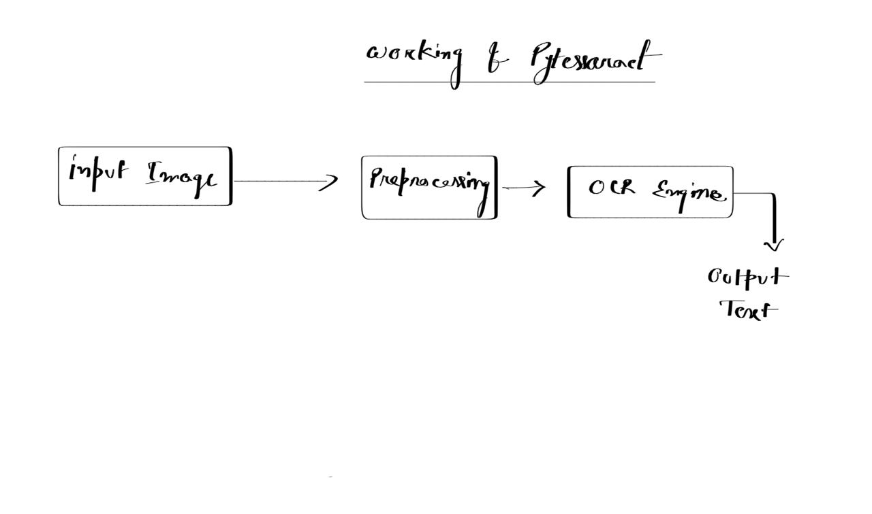
In essence, Pytesseract combines the powerful capabilities of Tesseract OCR with the flexibility and simplicity of Python, enabling efficient text extraction from images. Through a well-defined methodology and workflow, Pytesseract covers the entire process from preprocessing images to configuring OCR settings and handling output in various formats, providing a comprehensive toolkit for integrating OCR functionality into Python applications.
Figure 3.1 – Working Of Pytesseract 1

3.2. Tools Required
- Python
Python is a popular programming language known for its ease of use and versatility.Python's syntax is clear and reads almost like natural language,Despite its simplicity,Python can handle complex tasks.It's used for web development,dataanalysis,machine learning (including image detection!) and more.Python boasts a vast collection of pre-written code (libraries) for various functionalities.This saves you time by providing ready-made tools for common tasks.Python is free to use and modify,with a large and active community that contributes to its development and provides support.Python's simplicity and strong libraries make it ideal for our image detection project.Its clear syntax lets us develop code quickly, while libraries like OpenCV handle image loading, manipulation, and even pre-trained object detection models. This saves us time and effort, allowing us to focus on the core detection task. Python's active community also ensures ample resources for troubleshooting and learning.
- Flask
Flask is a lightweight web framework written in Python. Unlike larger frameworks, Flask focuses on being simple and easy to use. It provides the core building blocks for web applications, like handling URLs and connecting to databases, but lets you choose additional features from libraries as needed. This makes Flask flexible and ideal for quickly building small to medium-sized web apps.FLask prioritizes developer experience, making it popular for rapid prototyping, APIs, and lightweight web applications. Flask can be a great tool for building a text detection project. Flask's minimalist approach lets you develop a web app quickly without complex configurations. You can integrate powerful computer vision libraries like OpenCV for image processing and text detection algorithms. Flask can create a user-friendly interface using HTML and Javascript. Flask handles user interactions and routes image data to your text detection code.This code, written in Python, would likely use OpenCV and an OCR (Optical Character Recognition) engine like Tesseract to locate and recognize text within the image. Extracted text can be displayed on the web app for easy viewing or further processing. In essence,Flask provides the web framework to connect user input with your text detection logic, making it a valuable tool for creating a text detection project.

- FlaskDropZone
Flask-Dropzone is a tool that simplifies adding drag-and-drop file uploads to your Flask web applications. It combines two technologies:
- Flask: A Python framework for building web applications.It handles things like routing and templating.
- Dropzone.js: A JavaScript library that turns a browser area into a drag-and-drop zone for files.It provides features like progress bars and image previews.
Flask-Dropzone makes it easy to integrate these two. You install it like any other Python package and configure it in your Flask app. Then you can use Jinja templates to create the upload zone on your webpage. Uploaded files are handled by Flask routes, allowing you to save them or process them further. Overall, Flask-Dropzone saves you time by giving you a pre-built solution for drag-and-drop file uploads in Flask.
- WTForms
WTForms is a Python library that simplifies creating and managing forms in web development. It works with different web frameworks and template engines, giving you flexibility in building your application. WTForms helps you with:
- Form creation: Define forms using Python classes with fields like text input, password, or checkboxes.
- Validation: Set rules to ensure users enter data correctly, like minimum characters for a username. WTForms will catch errors and display messages to the user.
- Rendering: WTForms can automatically generate the HTML code for your form, but you can also customize how it appears in your templates.
- Security: WTForms helps protect your application from a common web attack (CSRF) that could hijack user sessions.
Overall, WTForms saves you time and effort by handling common form tasks, letting you focus on the core functionality of your web application. WTForms helps build the user interface and handle user input within your text detection web application. It doesn't directly perform text detection but contributes to the overall development process.

- Pytesseract
Pytesseract is a free and popular tool used to convert text within images into editable text. It's like having a reading assistant for your computer! In simpler terms, imagine you have a scanned document or a photo with text on it. Pytesseract, which works with Python programming language, can look at that image and decipher the words, turning them into regular text you can copy, paste, and search. It's like magic, but it's actually called Optical Character Recognition (OCR). Pytesseract is a wrapper for a powerful OCR engine called Tesseract, developed by Google. Pytesseract acts as a bridge between Python and Tesseract, a powerful Optical Character Recognition (OCR) engine. By using Pytesseract, your text detection project gains the ability to extract text from images. That is how pytesseract helps us to build text Recognition project.
- Data Automation: Pytesseract can automate data entry by pulling text from invoices,receipts, or any image containing relevant information.
- Document Digitization: Convert physical documents into searchable and editable digital formats by extracting the text content.
- Image Analysis: Extract text from various image sources for further analysis or processing.
Pytesseract simplifies integrating OCR into your Python projects, making text detection tasks more manageable. Here to get the text from the image we usedimage_to_data(img) function. this function we used to get the result of an image. In This function it require one parameter which is the location of the image. It will take the location and then extract the meaningfull insight from the image.
- OpenCV
OpenCV, short for Open-Source Computer Vision Library, is a free and powerful tool for computer vision tasks. Imagine giving a computer the ability to see and understand images and videos. That's what OpenCV helps programmers achieve. With over 2500 algorithms, OpenCV can be used for real-time processing on tasks like object detection , facial recognition and even creating 3D models from images. Originally developed by Intel, OpenCV is now maintained by a large community and works across various platforms like Windows, Mac, and even mobile devices.
OpenCV itself doesn't directly recognize text, but it provides the tools to prepare an image for a separate Optical Character Recognition (OCR) engine. Steps it takes to recognize an image:
- Image Preprocessing: OpenCV helps you load and manipulate the image. You can sharpen edges, convert to grayscale, and remove noise - all to make text clearer.
- Text Localization: OpenCV can find regions likely containing text. This often involves analyzing shapes and contours within the image to identify text blocks.
- Feeding to OCR: Once OpenCV isolates text areas, you can hand them off to an OCR engine like Tesseract. This engine deciphers the actual characters within the text block.
By providing a clean image and identifying text locations, OpenCV acts as a powerful pre-processing step for accurate text recognition with OCR. The function used in this project.
- imread(location): It takes one parameter which is location of the image. We are used this function to process the image. This function is provided by openCV. function is used to load an image from a specified file path (location). It returns a data structure (often a matrix) representing the image. If successful, you can then manipulate or display the image. It is used for load images for computer vision tasks like processing,analysis, or display.
- cvtColor( image, cv.color ) : The cv2.cvtColor(image, cv.color) function in OpenCV is used to convert an image from one color space to another. It takes two main arguments:
- Image: : The image you want to convert (often referred to as src in documentation).
- Color conversion code: This code specifies the target colorspace.OpenCV offers over 150 conversion codes, like cv2.COLOR_BGR2GRAY to convert from BGR to grayscale or cv2.COLOR_BGR2HSV for BGR to Hue-Saturation-Value.
OpenCV uses BGR color format by default, so be mindful of that when specifying conversions from RGB-based formats. The converted image is returned by the function.

- GTTS
Google Text-to-Speech (gTTS) is a tool that converts written text into spoken audio files, typically MP3s. It's particularly useful for programmers because it comes as a Python library. You can integrate gTTS into your programs to make them speak information or announcements. While gTTS is a free and easy option, it relies on Google Translate's text-to-speech engine, which may not be the most advanced. There's a limited range of voices, and customization options are few. Function we used in GTTS:
- gTTs( text, language ): gTTS stands for Google Text-to-Speech. It's a Python library that lets you convert text to spoken audio files (MP3).It takes two paramete. One is the text, basically the text which is converted to a audio. Next is the language, To which language the audio is converted to. Here's the gist:
- Input: You provide the text you want spoken and a language code (e.g., "en" for English, "es" for Spanish).
- Output: gTTS generates an MP3 file containing the spoken text in your chosen language.
gTTS is handy because it taps into Google Translate's text-to-speech engine. This means it supports a wide range of languages and offers different regional accents through the tld parameter. While it can't change the speaker's voice itself, gTTS is a great tool for creating basic audio files from text in various languages.
- save ( location ): It is used for save the speech or audio inside a folder. The save(location) function in Google Text-to-Speech (gTTS) lets you control where your converted speech is saved as an MP3 file. Location argument specifies the filename and optionally the directory path for the MP3. If you only provide a filename (e.g., "myfile.mp3"), it's saved in the current working directory where your script runs. Without save(location), gTTS saves the MP3 in the current working directory with a generic name. In essence, save(location) gives you control over the MP3's filename and location on your computer.

3.3. Model Selection
- Tesseract:
Tesseract is a powerful and widely used Optical Character Recognition (OCR) engine. Originally developed by Hewlett-Packard, it rose to fame for its accuracy and speed in recognizing printed text. In 2005, it became a free, open-source project, making it a popular choice for developers. Tesseract shines with its ability to handle various languages and operating systems like Linux, Windows, and macOS. It excels at turning scanned documents and images into editable text. This makes it a valuable tool for tasks like document archiving, data extraction, and creating accessible versions of physical materials. However, Tesseract has limitations. Handwritten text or images with complex layouts can prove challenging for it. While it's constantly improving, it might not be the best choice for those specific scenarios. Despite these limitations, Tesseract's open-source nature and strong performance with common use cases make it a compelling option for many text recognition projects. It's a great starting point for developers and offers a solid foundation for building your own OCR application.
- easyOCR
EasyOCR is a Python library designed to make Optical Character Recognition (OCR) accessible and user-friendly. It simplifies the process of extracting text from images for developers of all experience levels. It is Simple and User-Friendly, EasyOCR boasts a clean API, allowing you to focus on core functionalities without getting bogged down in complex configurations. It has Multilingual Support. It tackles text in over 80 languages, including popular scripts like Latin, Arabic, and Chinese. This makes it versatile for projects with diverse text requirements. It also has Flexibility. EasyOCR works with various image formats and can handle text embedded in natural scenes or dense documents. While EasyOCR excels in user-friendliness, it's important to note its limitations. It primarily focuses on recognizing printed text and might not be ideal for complex handwritten documents. Overall, EasyOCR is a strong choice for developers seeking an easy-to-use and versatile OCR solution for their Python projects, especially those dealing with multilingual text in images.
- Cloud-Based Models:
Cloud-based models offer a powerful and convenient approach for text detection projects. These models, provided by services like Google Cloud Vision API, Microsoft Azure Computer Vision, and Amazon Textract, leverage pre-trained deep learning models on massive datasets. This translates to high accuracy in detecting text across various scenarios, including printed text, handwritten text, and even text in complex layouts like images of documents.
A significant advantage of cloud-based models is their scalability. You don't need to worry about managing computational resources or training your own model. Simply send your image to the cloud service, and it returns the detected text data. This ease of use makes them ideal for projects where fast integration and minimal development effort are crucial.However, there are some trade-offs to consider. Cloud-based models typically incur usage fees based on the number of images processed. Additionally, these models are constantly evolving, and access to the latest improvements might require subscribing to higher service tiers. Finally, since your data is processed on a remote server, security considerations are essential, especially if handling sensitive documents.
Overall, cloud-based models are a compelling option for text detection projects that prioritize ease of use, scalability, and high accuracy. By understanding the strengths and limitations, you can determine if a cloud-based model is the best fit for your specific needs.
- DocTR:
DocTR (Document Text Recognition) is a rising star in the world of text detection projects. Unlike traditional OCR engines that focus on line-by-line text extraction, DocTR excels at pinpointing text in complex document images. It can handle layouts with varying orientations, like receipts, invoices, or historical documents with tilted text. This makes DocTR ideal for projects where text might be embedded in images with non-textual elements like tables, diagrams, or backgrounds. Its high accuracy ensures it captures all the text within the document, even in cluttered environments.However, there are some things to consider. DocTR is a relatively new model, and while it shows impressive results, it might not be as widely supported as established options like Tesseract. Additionally, DocTR is typically accessed through cloud APIs like Roboflow, which can incur usage fees depending on your project volume.
Overall, DocTR offers a powerful solution for projects demanding precise text detection in complex document images. If accuracy and layout flexibility are crucial, DocTR is definitely worth exploring, especially for those comfortable working with cloud-based platforms.
- OpenAI GPT-4 with Vision: OpenAI's GPT-4 with Vision is a cutting-edge model that might be a good fit for your text detection project, but with some caveats. This powerful tool combines image recognition with text generation, allowing it to not only see text in an image but also understand its context. This opens doors for projects that require interpreting text within its surroundings.
However, for a purely text detection project, GPT-4 with Vision might be overkill. Established OCR (Optical Character Recognition) engines like Tesseract or EasyOCR are specifically designed for this task and often offer higher accuracy and faster processing speeds. Additionally, GPT-4 with Vision is still under development and access might be limited.

3.4. Model Ready
Upon thorough comparisons, it becomes evident that the Tesseract model exhibits exceptional performance. Consequently, this model emerges as the preferred and final choice for the text detection task. The decision to select tesseract is rooted in its consistently superior performance. This outcomesignifies that tessarect outperforms alternative models, demonstrating its efficacy in generating high-accuracy text. The careful consideration of these comparative analyses reinforces the confidence in the suitability and effectiveness of the tessarect model, making it the optimal choice for the detecting process.
Why Tesseract:
There are several compelling reasons why Tesseract is an excellent choice for our text detection project. Firstly, it's an open-source OCR (Optical Character Recognition) engine, freely available under the Apache 2.0 license. This translates to no licensing fees and the ability to modify the code to fit our specific needs, should the need arise. Additionally, Tesseract boasts impressive language support, recognizing over 100 languages. This makes it a versatile tool, capable of handling multilingual projects without requiring additional language packs. Another key advantage is Tesseract's efficient integration with popular programming languages and frameworks. Through wrappers like PyTesseract for Python, we can seamlessly leverage Tesseract's functionalities within our project's codebase. This simplifies development and streamlines the process of incorporating OCR into our application.Tesseract's ability to perform both text detection and OCR in a single step is another benefit worth considering. This streamlines the development process compared to approaches that require separate modules for text localization and character recognition. While more advanced text detection methods might exist, Tesseract offers a good balance between accuracy, simplicity, and ease of use, making it a strong choice for many projectcs.
Furthermore, Tesseract offers a good balance between accuracy and performance. While not the absolute pinnacle of OCR technology, it delivers solid results for many use cases. This makes it a practical choice, especially for projects where achieving peak accuracy might not be the top priority. Tesseract 4.0 introduced a neural network-based engine that offers improved accuracy compared to its predecessor.
Finally, Tesseract's well-established reputation and large user base are valuable assets. A vast amount of documentation and tutorials exist online, making it easy to find solutions and troubleshoot any issues that might arise during development. This extensive community support ensures we can readily access help and guidance if needed. In conclusion, Tesseract's open-source nature, language support, ease of integration, accuracy, and strong community backing make it a powerful and cost-effective solution for our text detection project. It provides a solid foundation upon which we can build our application's OCR capabilities.
Working of Tesseract:
Tesseract is a powerful open-source tool for Optical Character Recognition (OCR), which essentially turns images of text into editable text. Here's a breakdown of its working process along with a diagram for better understanding: Stages of Tesseract OCR:
- Preprocessing:The input image is preprocessed to enhance the quality of text for better recognition. This might involve noise reduction, skew correction, and binarization (converting the image to black and white).
- Character Segmentation:Tesseract separates individual characters from the image. It identifies connected components (blobs) of foreground pixels likely representing characters and groups them into lines based on their proximity.
- Feature Extraction:For each character, specific features are extracted that help distinguish it from others. These features could be aspects like aspect ratio, number of connected components, and presence of holes.
- Character Recognition:An internal pattern recognition engine compares the extracted features of each character with stored patterns in its trained model. The most likely match is considered the recognized character. Tesseract uses a two-pass approach for better accuracy.
- Post-processing:The recognized characters are assembled into words and lines, and further corrections are made based on language context and dictionary information.
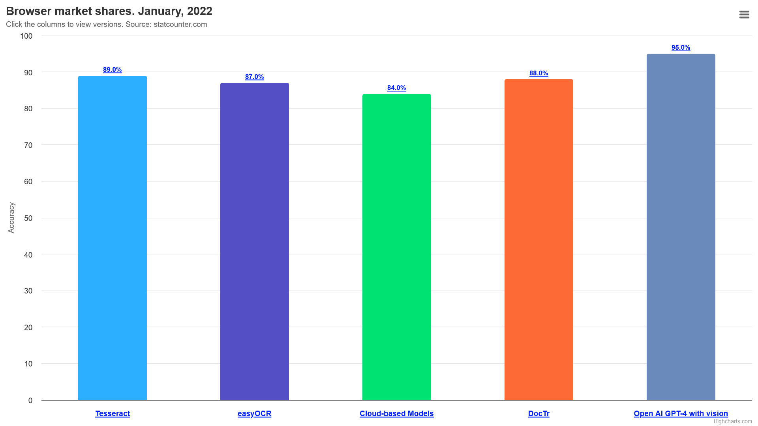
Accuracy Of Different Models:
Figure 3.2 – Accuracy of Different Models 2
The image clearly illustrates that various models yield varying levels of accuracy when it comes to text extraction from an image. Pytesseract, a popular OCR (Optical Character Recognition) tool, demonstrates an accuracy rate of 89%. Another OCR tool called easyOCR achieves a slightly lower accuracy of 87%. The cloud-based model, which is not specified, performs at 84% accuracy. DocTR, another model, achieves an accuracy rate of 88%. However, the OpenAI GPT-4 model with vision surpasses all the other models with an impressive accuracy of 95%.
Based on the graph provided, it is evident that the GPT-4 model should be utilized for text extraction from images due to its superior accuracy. However, despite its high accuracy, we decided to opt for pytesseract for our specific use case. This decision was primarily driven by the fact that pytesseract seamlessly integrates with the Python programming language, making it an ideal choice for our model implementation.
While GPT-4 may offer the highest accuracy, its integration and implementation may require more resources and effort. On the other hand, pytesseract's compatibility with Python allows for easier integration into our existing codebase and workflow. Additionally, pytesseract has proven to be reliable and efficient for our text extraction needs, even though it may not achieve the highest accuracy compared to other models.
In conclusion, while the GPT-4 model may be the most accurate option for text extraction from images, we chose to use pytesseract due to its seamless integration with Python and its satisfactory accuracy rate of 89%. This decision was made based on our specific requirements and the ease of implementation.

Chapter 4- Results and Discussion
4.1. Plain Text
In this process, we provide a plain text as input to the module. The module then generates an accurate result by accurately detecting the image and extracting the text from it. The extracted text is returned and displayed in the designated text field.

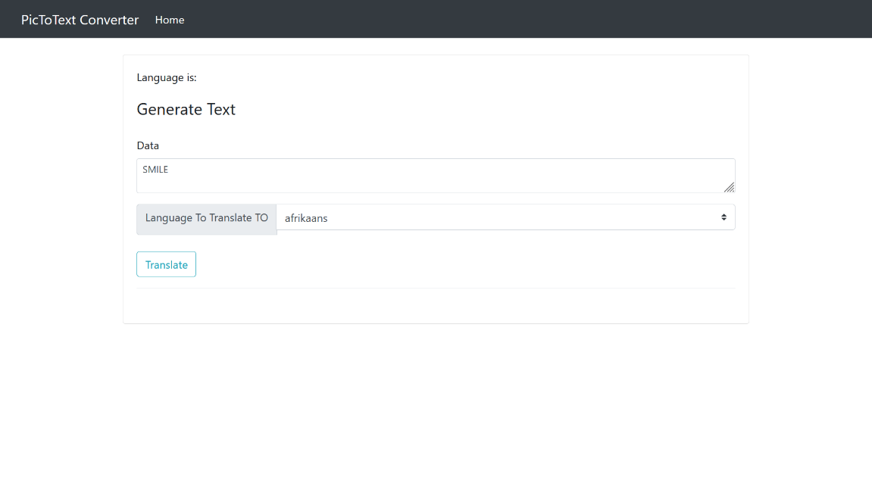
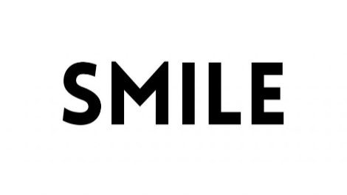

Figure 4.1 - Plain Text Detection 3
4.2. Short Text
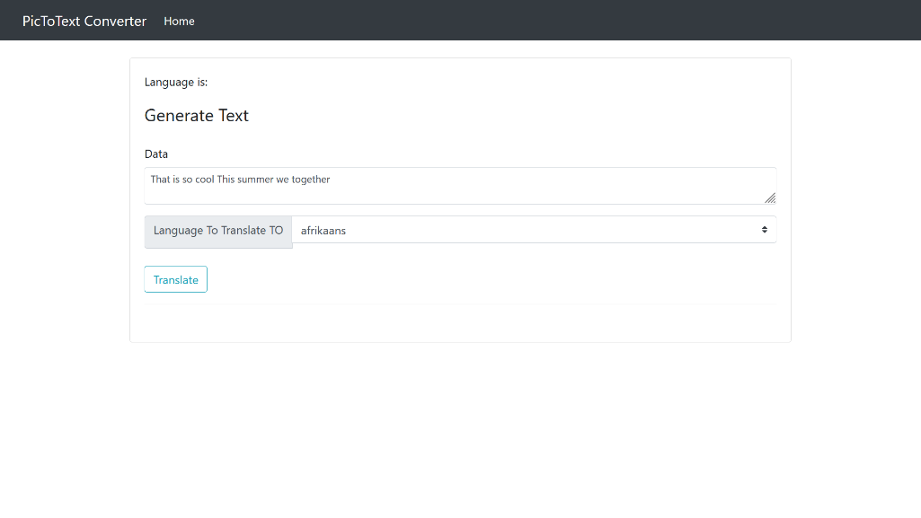
Within this module, a brief text is provided, typically around 10 characters or just a single sentence. The accuracy of the output is reliable, as it effectively detects the image and extracts the text. Users have the capability to input a sentence into the module, which then extracts the text for display in the text field. Should the user wish to make any edits to the extracted text, they can conveniently do so within the text field.
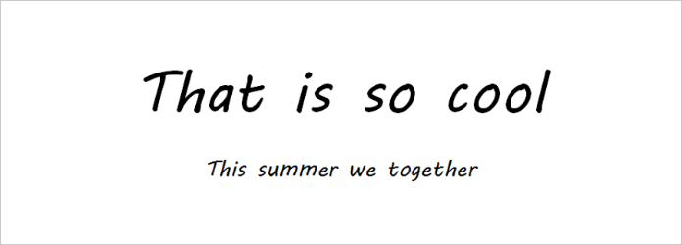

Figure 4.2 - Short Text Detection 4
4.3. Long Text
This makes it a valuable tool for researchers, students, and professionals who need to analyze and extract information from large volumes of text quickly and efficiently. The module's advanced algorithms and machine learning capabilities enable it to accurately interpret and extract text from various Images, making it a versatile and reliable tool for text processing tasks. Its ability to handle lengthy texts and extract information accurately makes it a valuable asset for any individual or organization.
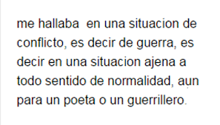
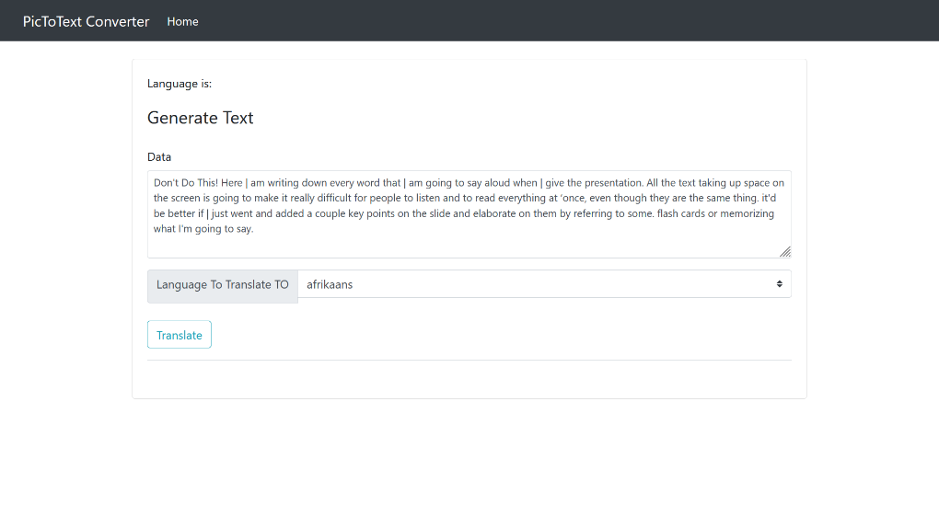
Figure 4.3 - Long Text Detection 5

  - . Handwritten Text
The functionality of this module extends to the detection of handwritten text as well. By providing an image of handwritten text, the module is capable of extracting the text from it. However, a notable drawback of this module is its lack of consistent accuracy in producing the desired output. At times, the output may not be entirely precise, while at other times it may be accurate. Consequently, when it comes to handwritten text, the module does not perform as effectively as it does with plain text. Thus, this module is limited in its effectiveness with handwritten text.
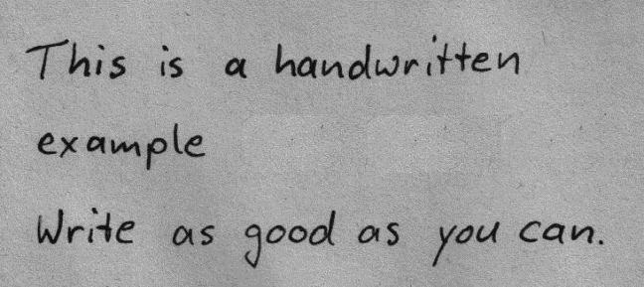
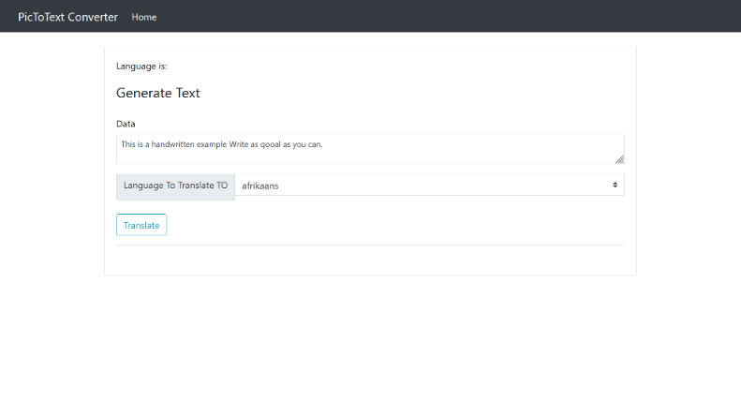
Figure 4.4 - Handwritten Text Detection 6
4.5. Other Languages
The module is designed to detect various languages, including Spanish, Italian, Japanese, and more. When a user provides an image containing text in a different language, such as Spanish, Italian, or Japanese, this module accurately identifies and detects the text in that specific language. In addition to English, thismodule has the capability to accurately detect and analyze text in multiple languages, making it a versatile tool for users who work with diverse language content.

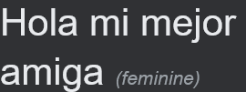
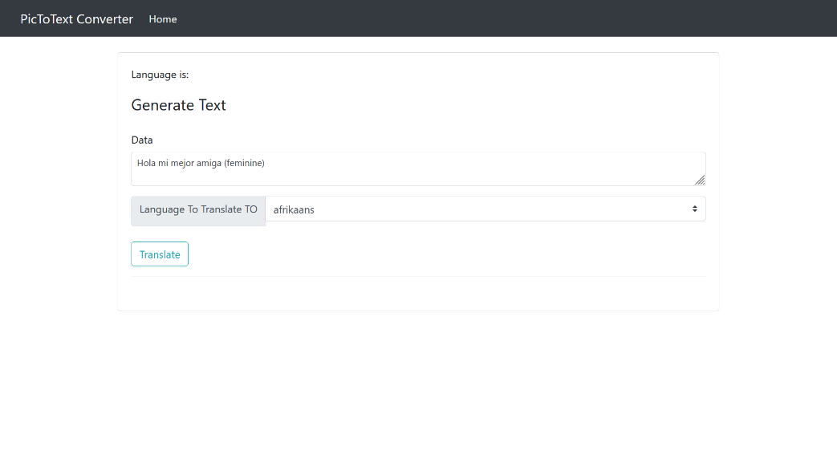
Figure 4.5 – Different language Text Detection 7
4.6. Convert Text
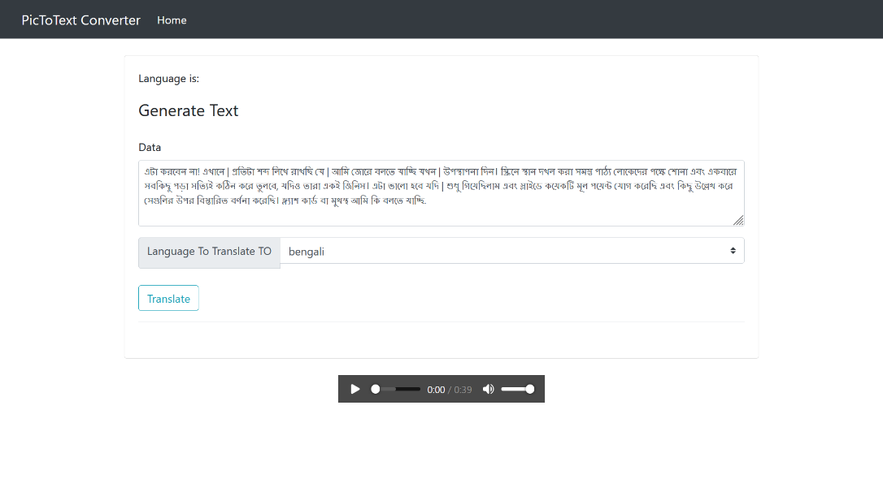
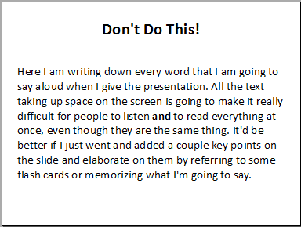
This module is not limited to just detecting text from an image; it also possesses the capability to translate the text into various languages. In cases where an image contains text in a language that the user is unable to comprehend, this module allows for the conversion of the text into a language that the user can understand.
Figure 4.6 - Text Conversion 8

4.7. Audio Generation
The purpose of this module is not to identify and translate text into various languages. Instead, its main function is to create an audio representation of the text extracted from an image. This feature greatly enhances the user's comprehension of the text, making it more valuable and easily understandable. By converting text into audio, this module caters to individuals who may have difficulty reading or understanding written text, such as those with visual impairments or learning disabilities. It also provides a convenient way for users to consume information on the go, as they can listen to the audio representation while multitasking or engaging in other activities. Furthermore, this module can be particularly useful in educational settings, where students can benefit from hearing the text read aloud to them. This auditory reinforcement can aid in retention and comprehension, ultimately improving the learning experience for students of all ages. Overall, the primary goal of this module is to make information more accessible and inclusive for all users, regardless of their language proficiency or reading abilities. By offering an audio representation of text, this feature enhances the overall user experience and ensures that everyone has equal access to the content.

Table 1: Result Summary
Test Id | Test Case | Description | Expected | Result
T01 | Plain Text | Data related to plain text | Detect the plain text from the image | Pass
T02 | Short Text | Input should have 20 character or one sentence | Detect the sentence from the image of the text | Pass
T03 | Long Text | Input should have long paragraph | Detect the long paragraph from the image | Pass
T04 | Handwritten Text | Input should have handwritten text. Not plain text | Detect and recognize the text from the hand written text | Not Accurate. Sometime model give accurate result and sometime it doesn’t
T05 | Convert the text | Input could be any text.It convert to any specific language | It detect text and user can convert it to any languages | Pass
T06 | Convert the text | Input could be any text.It convert to any specific language | It detect text and user can convert it to any languages | Pass
T07 | Audio generation | Input could be any text. It detect the text and generate an audio of the text | It generate the audio of the text which is detected from the image | Pass

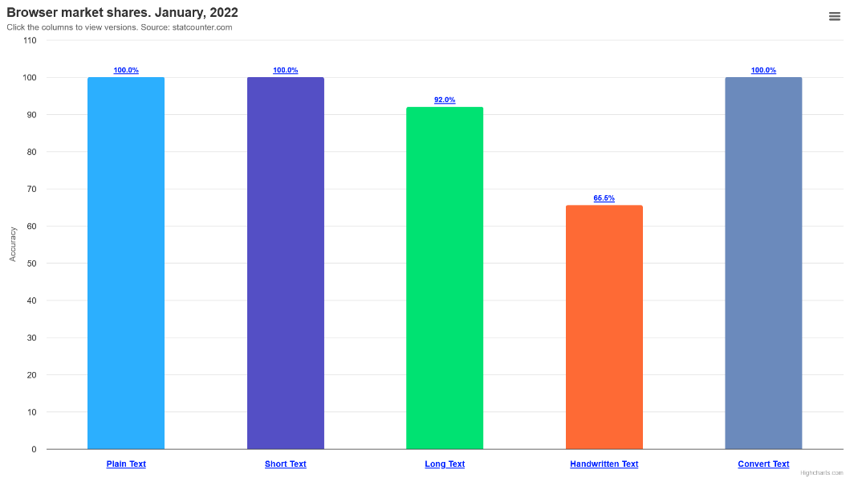
Accuracy Of Our Model:
Figure 4.7 – Accuracy Of our Model 9

The graph provides a visual representation of the performance of our text extraction model across different types of inputs. It clearly shows that the model performs exceptionally well when processing plain and short text inputs. This means that it is highly accurate in extracting relevant information from simple and concise texts.
However, the graph also highlights the limitations of our model when it comes to handling long text inputs. As the length of the text increases, the model's performance starts to decline. This indicates that the model struggles to accurately extract information from lengthy texts, which can be a significant drawback in real-world scenarios where long documents are common.
Additionally, the graph reveals that our model faces challenges when dealing with handwritten text. The accuracy of text extraction decreases significantly when the input is handwritten, suggesting that the model is not well-equipped to handle this type of input. This limitation is particularly important as handwritten text is prevalent in various domains, such as medical records or historical documents.
By analyzing the strengths and limitations depicted in the graph, we gain valuable insights that can guide our efforts to enhance the model's capabilities. We can focus on improving the model's performance when processing long text inputs, exploring techniques such as attention mechanisms or hierarchical modeling to better capture the context and structure of lengthy texts. Additionally, we can invest in research and development to address the challenges posed by handwritten text, potentially leveraging techniques like optical character recognition (OCR) or transfer learning from existing handwriting recognition models.
By addressing these areas of improvement, we can enhance the overall performance and usability of our text extraction model. This will enable us to provide more accurate and reliable results, regardless of the length or handwriting style of the input text. Ultimately, our goal is to develop a robust and versatile model that can effectively extract information from a wide range of text inputs, meeting the diverse needs of our users.

Chapter 5- Conclusion and Future Scope

Conclusion:
The project involved the utilization of pytesseract, a Python library, for text detection and extraction from images. This library allowed us to extract text from images and convert it into a readable format. To develop the project, we employed various tools such as Python, Flask, and Gtts. Python served as the primary programming language for the project, providing a robust and flexible environment for development. Flask, a web framework, was used to create a user-friendly interface for the web application. Gtts, which stands for Google Text-to-Speech, was used to generate audio from the extracted text.
The integration of these tools resulted in the creation of a web application that allowed users to upload images containing text. Once uploaded, the application utilized pytesseract to extract the text from the image and displayed it in a designated field. This feature enabled users to easily access and read the text without the need for manual transcription.
Furthermore, the application provided additional functionalities to enhance user experience. Users were able to edit the extracted text, making any necessary changes or corrections. Additionally, the application offered translation capabilities, allowing users to convert the text into different languages. This feature was particularly useful for users who needed to understand text in a language they were not familiar with.
One of the standout features of the project was the ability to generate audio from the extracted text. By utilizing Gtts, the application could convert the text into speech, providing an auditory representation of the image's content. This feature was especially beneficial for users with visual impairments or those who preferred to listen rather than read.
Overall, the project successfully integrated pytesseract, Python, Flask, and Gtts to develop a web application that allowed users to upload images containing text. The application provided text extraction, editing, translation, and audio generation capabilities, enhancing the accessibility and usability of the image's content.
Future Scope:
The project's future prospects involve enhancing the accuracy of handwritten text recognition. Currently, there are instances where the model fails to accurately detect text from handwritten images. Therefore, our primary objective is to improve the accuracy in such cases and introduce an additional feature known as text summarization. This feature will assist readers in comprehending the meaning of lengthy paragraphs that are generated as output from an image.

References

- Mrunmayee Patil, Ramesh Kagalkar. (Nov 2014). Conversion of Image to Text As Well As Speech Using Edge Detection and Image Segmentation.
- Ashwini V. Zadgaonkar , Rupali S. Vairagade. (nov 2019). An Approach for Translation of Text in Images using Deep Learning Techniques.
- Deepika S. (nov 2020). Image Processing and Text Extraction Python.
- Erram Aishwarya Reddy, Kasireddy Raghuvardhan Reddy, Mohammad Irshad. (nov 2020). Handwritten Text Recognition Using Machine Learning.
- Keerthi S H, Shravya, Laxmi V. (Nov 2023). Image to Text and Speech Synthesis.
- Min Cao, Shiping Li, Juntao Li, Liqiang Nile , Min Zhang. (Nov 2022). Image to text retrival.
- Neeru Saxena,Humera Parveen. (nov 2020). Text Extraction Systems for Printed Images.
- S. Venkateswarlu, D. B. K. Kamesh, J. K. R. Sastry and Radhika Rani. (nov 2020). Text to Speech Conversion.
- Swapnil Sinha, Harsh Kumar Kataruka, Vijaya Kumar Kuppusamy. (june 2020). Image to text converter and translator using Deep learning.
- Shilpa Mahajan and Rajneesh Rani.(April 2021). Text detection and localization in scene images: a broad review
- Ebin Zacharias, Martin Teuchler and Bénédicte Bernier.(April 2021). Image Processing Based Scene-Text Detection and Recognition with Tesseract

Appendix
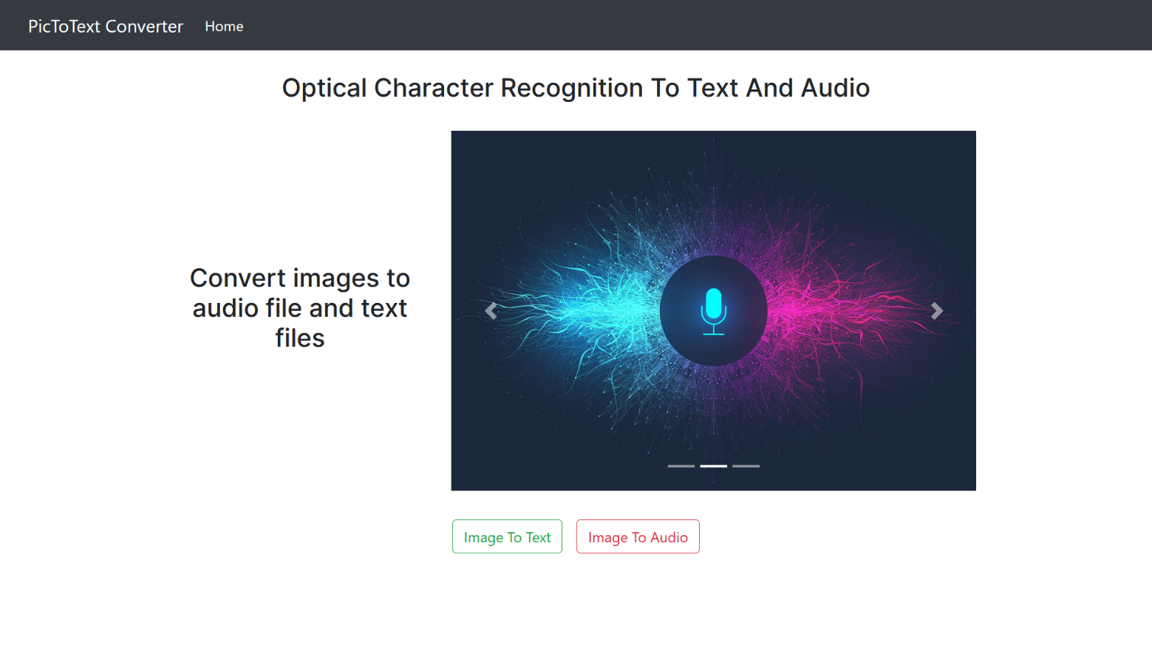
Figure - Front Page
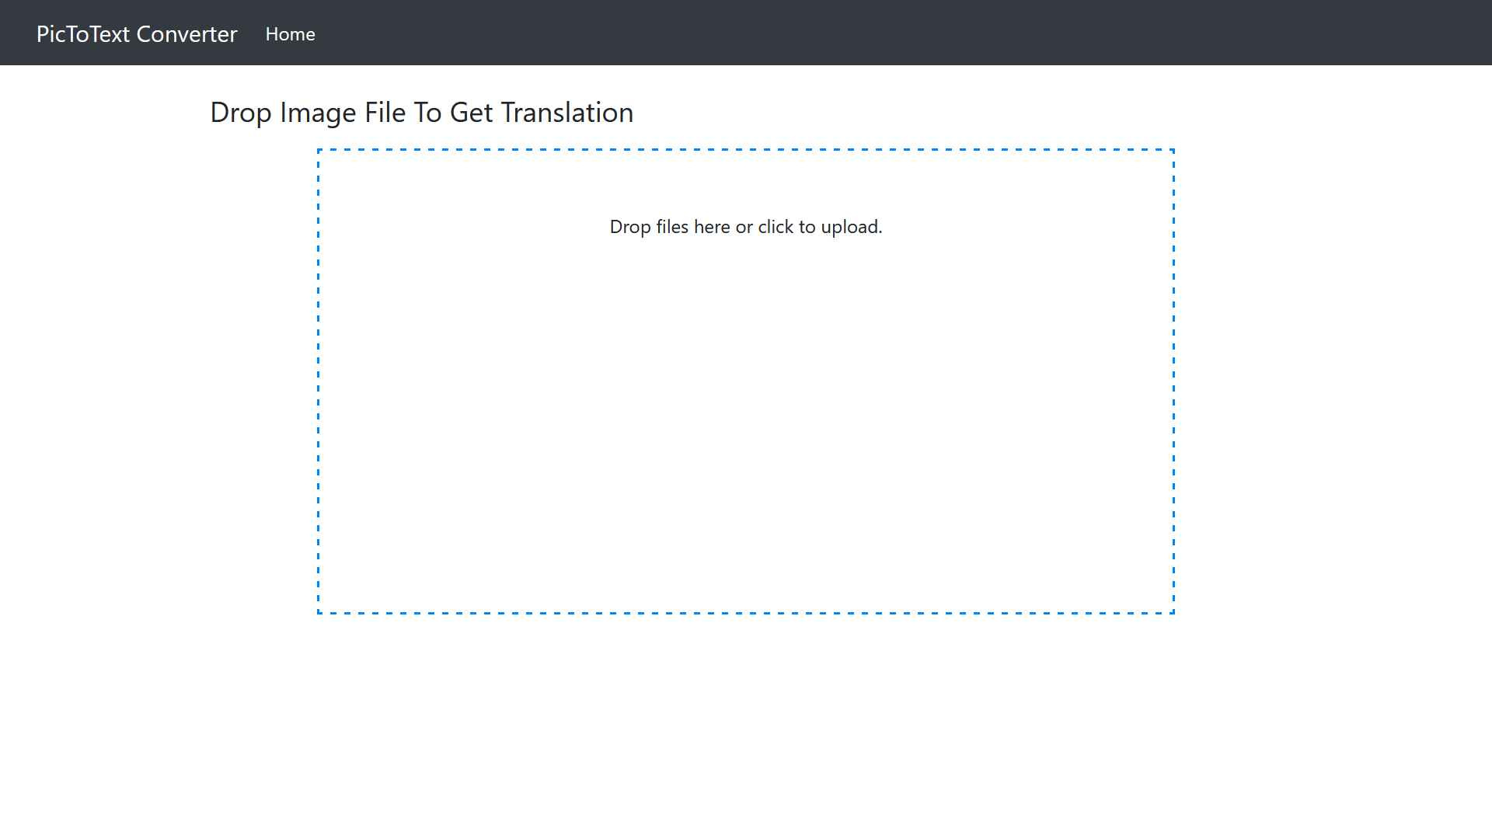
Figure – Drag and drop file
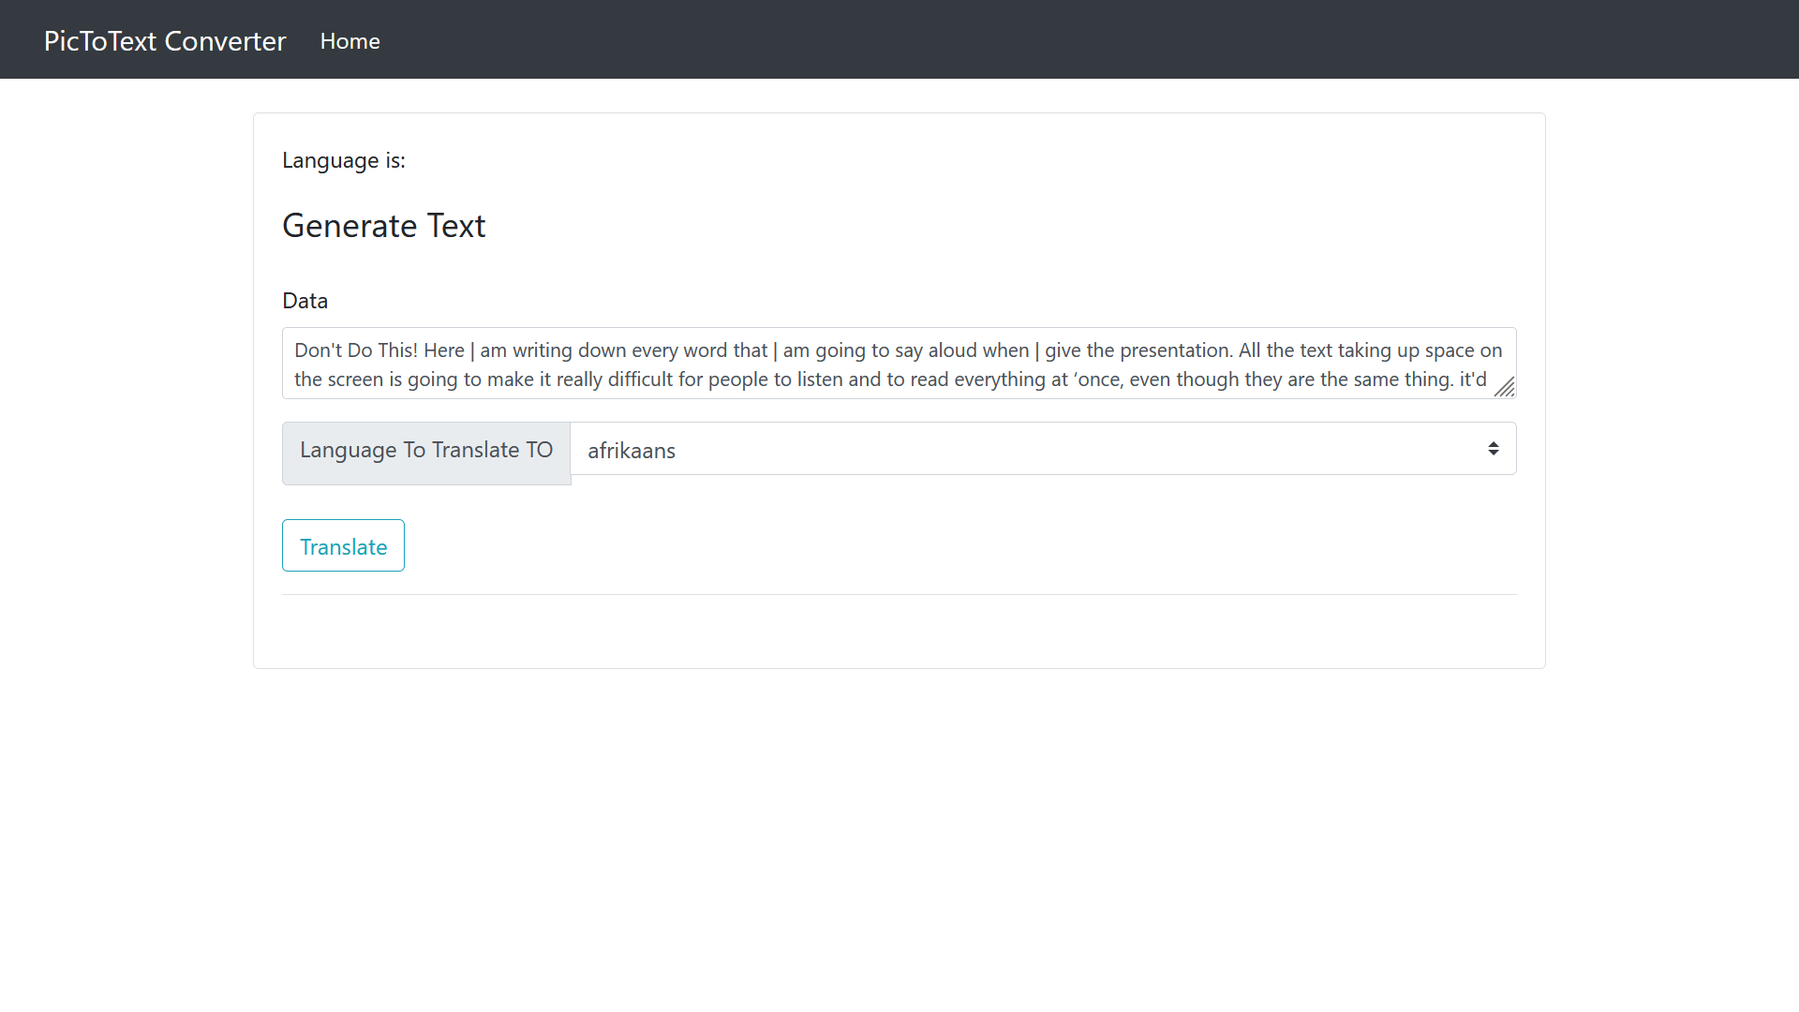
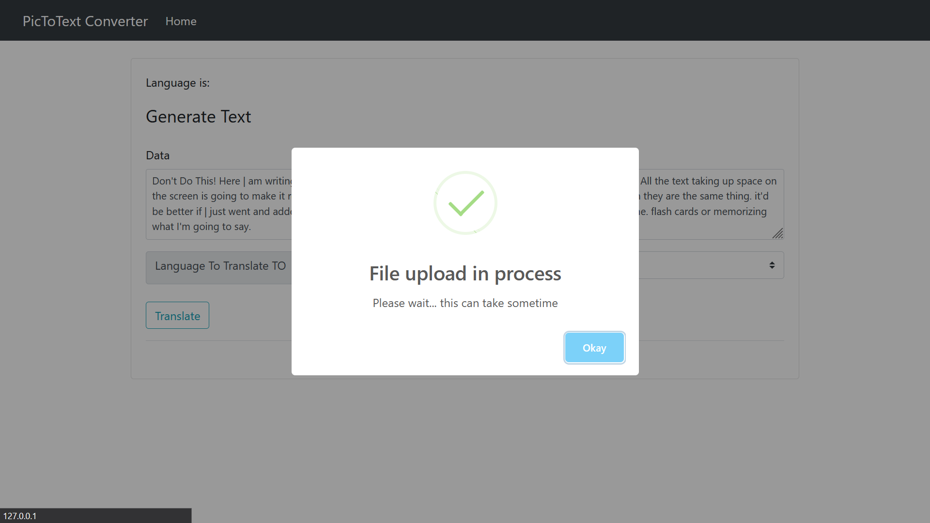
Figure – File upload page
Figure – User Interface
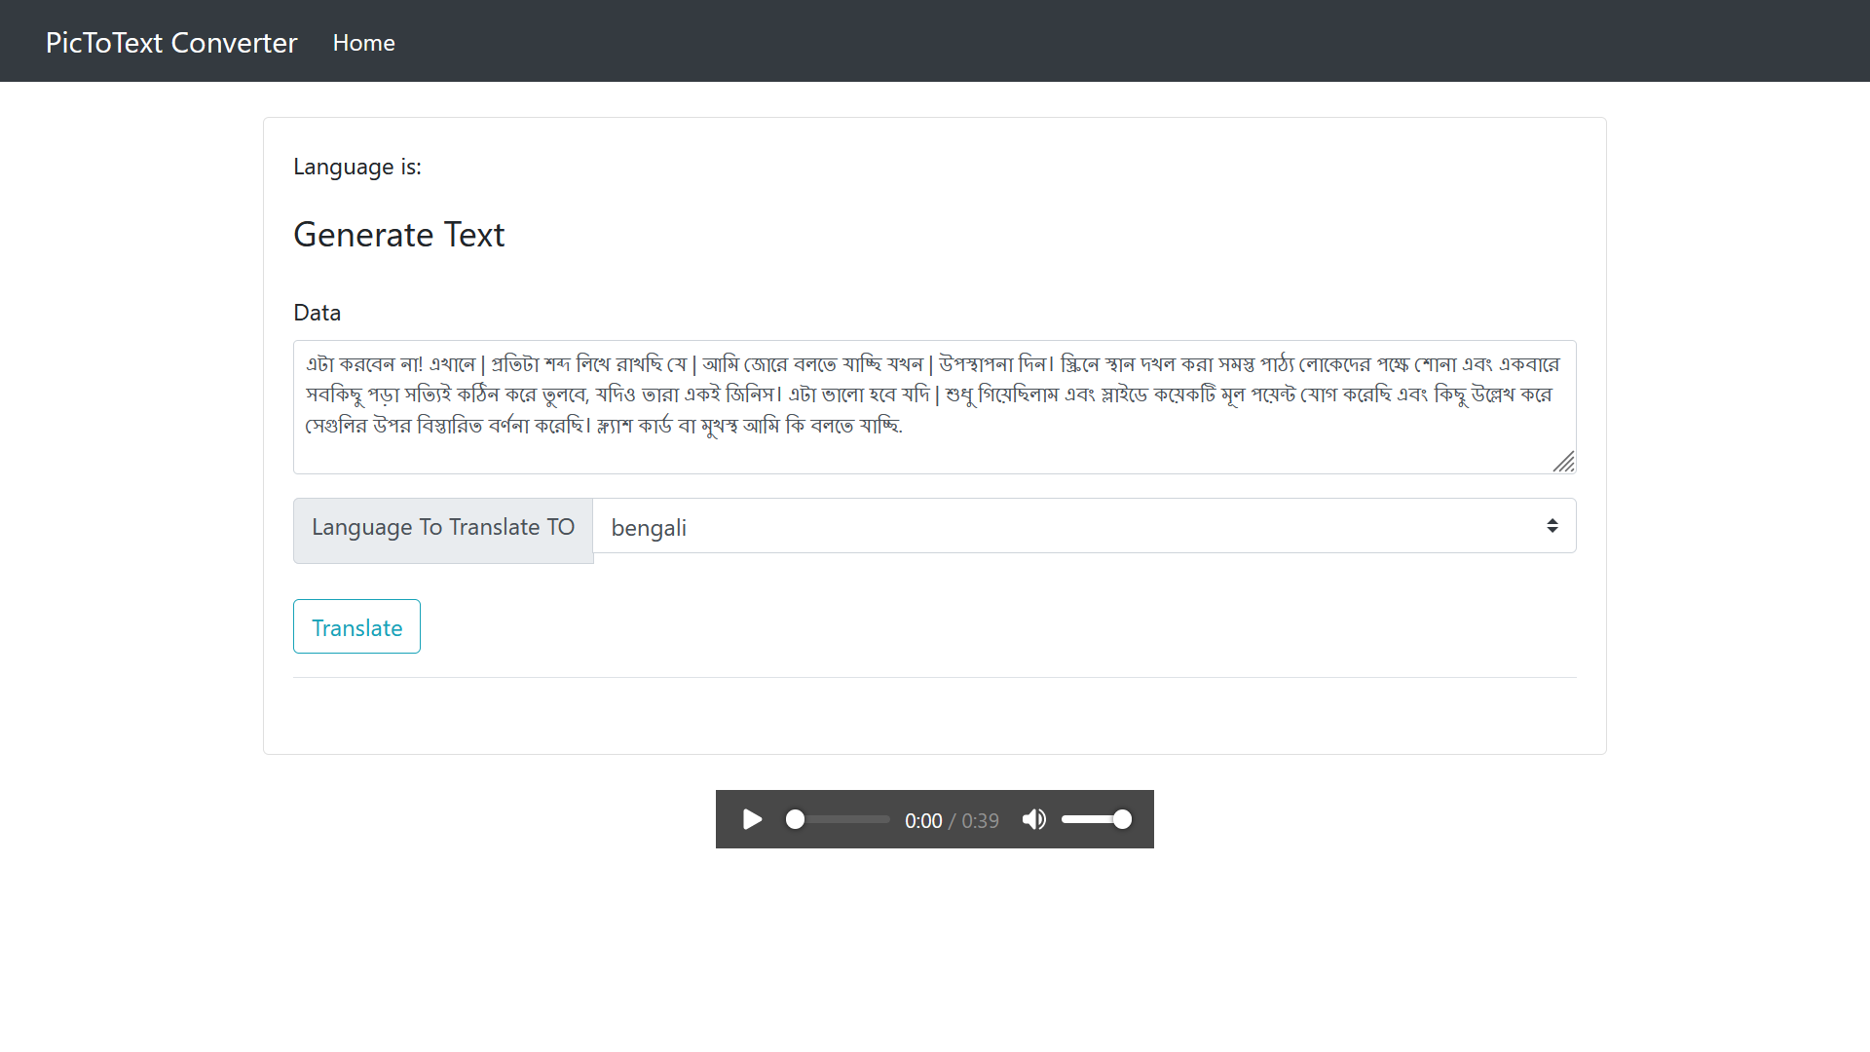
Figure – text conversion and audio generation page

